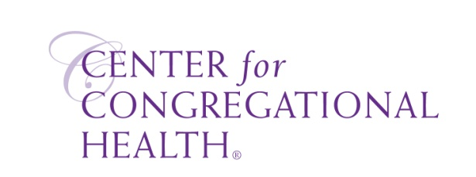

Phases of a Pastor Search Committee’s work
Dr. Bill Wilson

PHASE ONE: Getting acquainted

PHASE TWO: Preparation

PHASE THREE: Considering Candidates
The winnowing process
Three stages:
One: From initial group to 20 (Resumes)
Two: from 20 to 5-6 (Written responses, conversations, Skype)
Three: from 5-6 to 1 (Conversations, phone, video, visits)

PHASE FOUR: Contact/Interview/Discern
Going deep with a candidate…one at a time.

PHASE FIVE: Call, install, assimilate

